Angle Conditions

Definition
# Source: AI Source: Provided by: [Data Path: Persons Table -> ID Column: 1, Name_En Column: Motasem Essam] -> From: [ChatGPT] on [7/25/2026]
Angle Conditions are geometric conditions that specify, compare, or constrain the measures or relationships of angles in a geometric configuration.
An angle condition can specify an exact angle measure, equality between angles, an inequality between angles, a relationship between angles, or a special angular relationship such as perpendicularity or supplementary angles.
$$\boxed{\text{Angle Condition}=\text{Requirement involving an angle or angular relationship}}$$
Examples
$$m∠ABC={60}^{∘} \\ m∠ABC=m∠DEF \\ m∠A>m∠B \\ ∠A+∠B={180}^{∘} \\ ∠A={90}^{∘}$$

Simple Definition
# Source: AI Source: Provided by: [Data Path: Persons Table -> ID Column: 1, Name_En Column: Motasem Essam] -> From: [ChatGPT] on [7/25/2026]
An Angle Condition is a requirement that specifies or compares the measure or relationship of one or more geometric angles.
For example:
- “Angle $A$is ${60}^{∘}$” → $m∠A={60}^{∘}$
- “Two angles are equal” → $m∠A=m∠B$
- “The lines are perpendicular” → $m∠A={90}^{∘}$
- “Two angles are supplementary” → $A+B={180}^{∘}$

Main Types of Angle Conditions
# Source: AI Source: Provided by: [Data Path: Persons Table -> ID Column: 1, Name_En Column: Motasem Essam] -> From: [ChatGPT] on [7/25/2026]
A practical classification is:
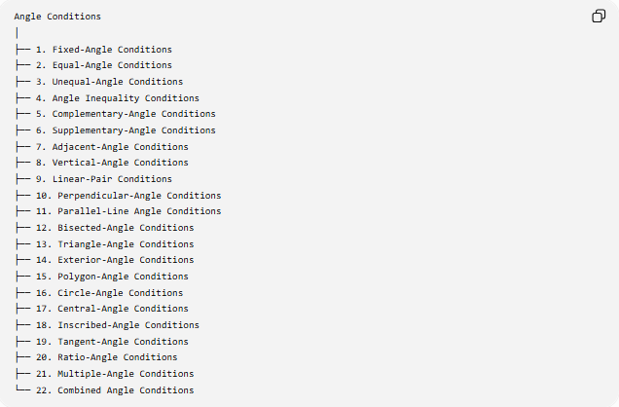
Angle Conditions
│
├── 1. Fixed-Angle Conditions
├── 2. Equal-Angle Conditions
├── 3. Unequal-Angle Conditions
├── 4. Angle Inequality Conditions
├── 5. Complementary-Angle Conditions
├── 6. Supplementary-Angle Conditions
├── 7. Adjacent-Angle Conditions
├── 8. Vertical-Angle Conditions
├── 9. Linear-Pair Conditions
├── 10. Perpendicular-Angle Conditions
├── 11. Parallel-Line Angle Conditions
├── 12. Bisected-Angle Conditions
├── 13. Triangle-Angle Conditions
├── 14. Exterior-Angle Conditions
├── 15. Polygon-Angle Conditions
├── 16. Circle-Angle Conditions
├── 17. Central-Angle Conditions
├── 18. Inscribed-Angle Conditions
├── 19. Tangent-Angle Conditions
├── 20. Ratio-Angle Conditions
├── 21. Multiple-Angle Conditions
└── 22. Combined Angle Conditions
This is a practical/descriptive classification, not a universally standardized taxonomy. Several categories can overlap.

1. Fixed-Angle Conditions
# Source: AI Source: Provided by: [Data Path: Persons Table -> ID Column: 1, Name_En Column: Motasem Essam] -> From: [ChatGPT] on [7/25/2026]
Definition
A Fixed-Angle Condition specifies that an angle has a particular constant measure.
$$\boxed{m∠ABC=θ}$$
where $θ$is fixed.
Example
$$m∠ABC={60}^{∘}.$$
This means the angle must always measure ${60}^{∘}$.
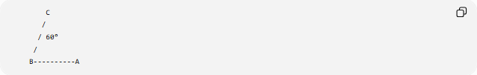
C
/
/ 60°
/
B----------A
Common Fixed Angles
$${30}^{∘}, {45}^{∘}, {60}^{∘}, {90}^{∘}, {120}^{∘}, {180}^{∘}.$$
A fixed-angle condition is particularly important in geometric construction.

2. Equal-Angle Conditions
# Source: AI Source: Provided by: [Data Path: Persons Table -> ID Column: 1, Name_En Column: Motasem Essam] -> From: [ChatGPT] on [7/25/2026]
Definition
An Equal-Angle Condition states that two or more angles have the same measure.
$$\boxed{m∠A=m∠B}$$
Example
If:
$$m∠ABC={50}^{∘}$$
and:
$$m∠DEF={50}^{∘},$$
then:
$$\boxed{∠ABC=∠DEF}.$$
Isosceles Triangle
If:
$$AB=AC,$$
then:
$$\boxed{∠ABC=∠BCA}.$$
Thus a length condition can produce an angle condition.

3. Unequal-Angle Conditions
# Source: AI Source: Provided by: [Data Path: Persons Table -> ID Column: 1, Name_En Column: Motasem Essam] -> From: [ChatGPT] on [7/25/2026]
Definition
An Unequal-Angle Condition states that two angles do not have equal measures.
$$\boxed{m∠A≠m∠B}$$
which means:
$$m∠A<m∠B$$
or:
$$m∠A>m∠B.$$
Example
$$m∠A={40}^{∘}, m∠B={70}^{∘}.$$
Therefore:
$$\boxed{∠A≠∠B}.$$

4. Angle Inequality Conditions
# Source: AI Source: Provided by: [Data Path: Persons Table -> ID Column: 1, Name_En Column: Motasem Essam] -> From: [ChatGPT] on [7/25/2026]
Definition
An Angle Inequality Condition compares two or more angle measures.
$$\boxed{m∠A>m∠B}$$
or:
$$\boxed{m∠A<m∠B}.$$
Non-strict forms are:
$$m∠A≥m∠B$$
and:
$$m∠A≤m∠B.$$
Example
In a triangle, if:
$$AB>AC,$$
then the angle opposite $AB$is larger than the angle opposite $AC$:
$$\boxed{∠C>∠B}.$$
This is the Side–Angle Inequality relationship.

5. Complementary-Angle Conditions
# Source: AI Source: Provided by: [Data Path: Persons Table -> ID Column: 1, Name_En Column: Motasem Essam] -> From: [ChatGPT] on [7/25/2026]
Definition
Two angles are complementary when their measures add to ${90}^{∘}$.
$$\boxed{A+B={90}^{∘}}$$
Example
If:
$$A={35}^{∘},$$
then:
$$B={90}^{∘}-{35}^{∘}={55}^{∘}.$$
Therefore:
$$\boxed{A+B={90}^{∘}}.$$
Geometric Example
The two acute angles of a right triangle are complementary:
$$\boxed{A+B={90}^{∘}}.$$

6. Supplementary-Angle Conditions
# Source: AI Source: Provided by: [Data Path: Persons Table -> ID Column: 1, Name_En Column: Motasem Essam] -> From: [ChatGPT] on [7/25/2026]
Definition
Two angles are supplementary when their measures add to ${180}^{∘}$.
$$\boxed{A+B={180}^{∘}}$$
Example
If:
$$A={120}^{∘},$$
then:
$$B={60}^{∘}.$$
Therefore:
$${120}^{∘}+{60}^{∘}={180}^{∘}.$$
Common Example
The interior angles on the same side of a transversal between parallel lines are supplementary:
$$\boxed{A+B={180}^{∘}}.$$

7. Adjacent-Angle Conditions
# Source: AI Source: Provided by: [Data Path: Persons Table -> ID Column: 1, Name_En Column: Motasem Essam] -> From: [ChatGPT] on [7/25/2026]
Definition
Adjacent-Angle Conditions involve two angles that share:
- a common vertex,
- a common side,
- and have non-overlapping interiors.
Example
If $∠ABC$and $∠CBD$are adjacent:
$$\boxed{m∠ABC+m∠CBD=m∠ABD}$$
when ray $BC$lies inside $∠ABD$.
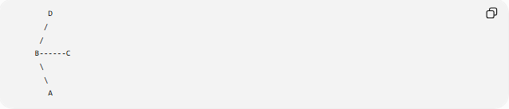
D
/
/
B------C
\
\
A
The shared side is $BC$.

8. Vertical-Angle Conditions
# Source: AI Source: Provided by: [Data Path: Persons Table -> ID Column: 1, Name_En Column: Motasem Essam] -> From: [ChatGPT] on [7/25/2026]
Definition
Vertical angles are opposite angles formed when two lines intersect.
The fundamental condition is:
$$\boxed{\text{Vertical angles are equal}}$$
Example
If two lines intersect:
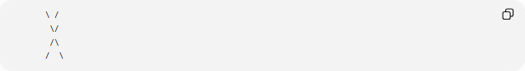
\ /
\/
/\
/ \
then opposite angles satisfy:
$$\boxed{A=C}$$
and:
$$\boxed{B=D}.$$
Important Formula
If:
$$m∠A={70}^{∘},$$
then its vertical angle is:
$$\boxed{{70}^{∘}}.$$

9. Linear-Pair Conditions
# Source: AI Source: Provided by: [Data Path: Persons Table -> ID Column: 1, Name_En Column: Motasem Essam] -> From: [ChatGPT] on [7/25/2026]
Definition
A Linear-Pair Condition occurs when two adjacent angles form a straight angle.
Therefore:
$$\boxed{A+B={180}^{∘}}.$$
Example
If:
$$A={110}^{∘},$$
then:
$$B={70}^{∘}.$$
because:
$${110}^{∘}+{70}^{∘}={180}^{∘}.$$
Important Distinction
Every linear pair is supplementary, but not every pair of supplementary angles necessarily forms a linear pair.

10. Perpendicular-Angle Conditions
# Source: AI Source: Provided by: [Data Path: Persons Table -> ID Column: 1, Name_En Column: Motasem Essam] -> From: [ChatGPT] on [7/25/2026]
Definition
Two lines are perpendicular when they intersect at a right angle.
$$\boxed{l_{1}⊥l_{2}}$$
means:
$$\boxed{m∠={90}^{∘}}.$$
Example
If:
$$AB⊥CD,$$
then all four angles formed by their intersection are:
$$\boxed{{90}^{∘}}.$$
Relationship
$$\boxed{\text{Perpendicular Lines}→\text{Right Angles}}$$

11. Parallel-Line Angle Conditions
# Source: AI Source: Provided by: [Data Path: Persons Table -> ID Column: 1, Name_En Column: Motasem Essam] -> From: [ChatGPT] on [7/25/2026]
When a transversal intersects parallel lines, several angle relationships become available.
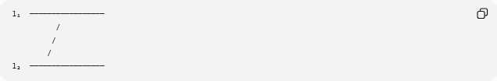
l₁ ─────────────────
/
/
/
l₂ ─────────────────
If:
$$l_{1}∥l_{2},$$
then:
Corresponding Angles
$$\boxed{A=B}$$
Alternate Interior Angles
$$\boxed{A=B}$$
Alternate Exterior Angles
$$\boxed{A=B}$$
Same-Side Interior Angles
$$\boxed{A+B={180}^{∘}}.$$
These are important angle conditions because parallelism creates predictable angular relationships.

12. Angle-Bisected Conditions
# Source: AI Source: Provided by: [Data Path: Persons Table -> ID Column: 1, Name_En Column: Motasem Essam] -> From: [ChatGPT] on [7/25/2026]
Definition
An Angle-Bisected Condition occurs when a ray or line divides an angle into two equal angles.
If ray $BD$bisects $∠ABC$:
$$\boxed{∠ABD=∠DBC}.$$
Therefore:
$$\boxed{m∠ABD=m∠DBC=\frac{1}{2}m∠ABC}$$
Example
If:
$$m∠ABC={80}^{∘},$$
then:
$$m∠ABD=m∠DBC={40}^{∘}.$$

13. Triangle-Angle Conditions
# Source: AI Source: Provided by: [Data Path: Persons Table -> ID Column: 1, Name_En Column: Motasem Essam] -> From: [ChatGPT] on [7/25/2026]
Definition
Triangle-angle conditions specify relationships among the three interior angles of a triangle.
The fundamental condition is:
$$\boxed{A+B+C={180}^{∘}}.$$
Example
If:
$$A={50}^{∘}, B={60}^{∘},$$
then:
$$C={180}^{∘}-{50}^{∘}-{60}^{∘} \\ \boxed{C={70}^{∘}}.$$
Triangle Classification
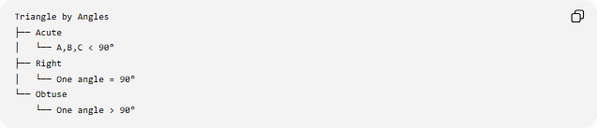
Triangle by Angles
├── Acute
│ └── A,B,C < 90°
├── Right
│ └── One angle = 90°
└── Obtuse
└── One angle > 90°

14. Exterior-Angle Conditions
# Source: AI Source: Provided by: [Data Path: Persons Table -> ID Column: 1, Name_En Column: Motasem Essam] -> From: [ChatGPT] on [7/25/2026]
Definition
An Exterior-Angle Condition relates an exterior angle of a triangle to its two remote interior angles.
The Exterior Angle Theorem states:
$$\boxed{E=A+B}.$$
Example
If:
$$A={50}^{∘}, B={60}^{∘},$$
then:
$$E={50}^{∘}+{60}^{∘} \\ \boxed{E={110}^{∘}}.$$
The exterior angle is also supplementary to its adjacent interior angle:
$$\boxed{E+C={180}^{∘}}.$$

15. Polygon-Angle Conditions
# Source: AI Source: Provided by: [Data Path: Persons Table -> ID Column: 1, Name_En Column: Motasem Essam] -> From: [ChatGPT] on [7/25/2026]
Definition
Polygon-Angle Conditions describe relationships among the interior or exterior angles of polygons.
For an $n$-sided polygon:
$$\boxed{S=\left(n-2\right){180}^{∘}}$$
where $S$is the sum of interior angles.
Example: Pentagon
For $n=5$:
$$S=\left(5-2\right){180}^{∘} \\ \boxed{S={540}^{∘}}.$$
Regular Polygon
For a regular $n$-gon, each interior angle is:
$$\boxed{A=\frac{\left(n-2\right){180}^{∘}}{n}}$$
and each exterior angle is:
$$\boxed{E=\frac{{360}^{∘}}{n}}.$$

16. Circle-Angle Conditions
# Source: AI Source: Provided by: [Data Path: Persons Table -> ID Column: 1, Name_En Column: Motasem Essam] -> From: [ChatGPT] on [7/25/2026]
Angles associated with circles create several important conditions.
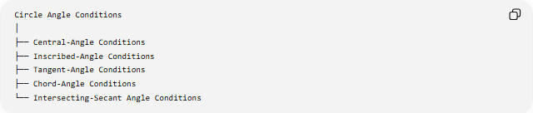
Circle Angle Conditions
│
├── Central-Angle Conditions
├── Inscribed-Angle Conditions
├── Tangent-Angle Conditions
├── Chord-Angle Conditions
└── Intersecting-Secant Angle Conditions

16.1. Central-Angle Conditions
# Source: AI Source: Provided by: [Data Path: Persons Table -> ID Column: 1, Name_En Column: Motasem Essam] -> From: [ChatGPT] on [7/25/2026]
Definition
A Central Angle has its vertex at the center of a circle.
Its measure equals the measure of its intercepted arc:
$$\boxed{m∠AOB=m\hat{AB}}$$
Example
If arc $AB$measures:
$${80}^{∘},$$
then:
$$\boxed{m∠AOB={80}^{∘}}.$$

16.2. Inscribed-Angle Conditions
# Source: AI Source: Provided by: [Data Path: Persons Table -> ID Column: 1, Name_En Column: Motasem Essam] -> From: [ChatGPT] on [7/25/2026]
Definition
An Inscribed Angle has its vertex on the circle.
Its measure is half the measure of its intercepted arc:
$$\boxed{m∠APB=\frac{1}{2}m\hat{AB}}$$
Example
If:
$$m\hat{AB}={100}^{∘},$$
then:
$$m∠APB=\frac{1}{2}\left({100}^{∘}\right) \\ \boxed{{50}^{∘}}.$$
Relationship with Central Angle
For the same intercepted arc:
$$\boxed{m∠_{\text{central}}=2m∠_{\text{inscribed}}}$$

16.3. Tangent-Angle Conditions
# Source: AI Source: Provided by: [Data Path: Persons Table -> ID Column: 1, Name_En Column: Motasem Essam] -> From: [ChatGPT] on [7/25/2026]
Definition
A tangent to a circle is perpendicular to the radius drawn to the point of tangency.
If $PT$is tangent at $T$:
$$\boxed{OT⊥PT}$$
so:
$$\boxed{m∠OTP={90}^{∘}}.$$
There are also angle conditions involving a tangent and chord:
$$\boxed{m∠\left(\text{tangent,chord}\right)=\frac{1}{2}m\left(\text{intercepted arc}\right)}$$
under the appropriate configuration.

17. Ratio-Angle Conditions
# Source: AI Source: Provided by: [Data Path: Persons Table -> ID Column: 1, Name_En Column: Motasem Essam] -> From: [ChatGPT] on [7/25/2026]
Definition
A Ratio-Angle Condition specifies that two or more angle measures have a fixed ratio.
$$\boxed{\frac{A}{B}=k}$$
Example
Suppose:
$$A:B=2:3$$
and:
$$A+B={180}^{∘}.$$
Let:
$$A=2x, B=3x.$$
Then:
$$2x+3x={180}^{∘} \\ 5x={180}^{∘} \\ x={36}^{∘}.$$
Therefore:
$$\boxed{A={72}^{∘}, B={108}^{∘}}.$$

18. Multiple-Angle Conditions
# Source: AI Source: Provided by: [Data Path: Persons Table -> ID Column: 1, Name_En Column: Motasem Essam] -> From: [ChatGPT] on [7/25/2026]
Definition
A Multiple-Angle Condition specifies several angular relationships simultaneously.
Example
A triangle may satisfy:
$$A={50}^{∘}, \\ B=2C,$$
and:
$$A+B+C={180}^{∘}.$$
Substitute:
$${50}^{∘}+2C+C={180}^{∘} \\ 3C={130}^{∘} \\ \boxed{C=\frac{{130}^{∘}}{3}}$$
and:
$$\boxed{B=\frac{{260}^{∘}}{3}}.$$
Multiple conditions can therefore be solved as a system of equations.

19. Combined Angle Conditions
# Source: AI Source: Provided by: [Data Path: Persons Table -> ID Column: 1, Name_En Column: Motasem Essam] -> From: [ChatGPT] on [7/25/2026]
Definition
A Combined Angle Condition contains several angular requirements that must hold simultaneously.
Example
Suppose:
$$A=B$$
and:
$$A+B={100}^{∘}.$$
Since:
$$A=B,$$
we have:
$$2A={100}^{∘}.$$
Therefore:
$$\boxed{A=B={50}^{∘}}.$$
Geometric Example
If:
$$AB∥CD$$
and a transversal creates:
$$A={70}^{∘},$$
then the corresponding angle is also:
$${70}^{∘},$$
while the adjacent supplementary angle is:
$${110}^{∘}.$$
Thus one angle condition can generate several additional conditions.

Angle Conditions and Loci
# Source: AI Source: Provided by: [Data Path: Persons Table -> ID Column: 1, Name_En Column: Motasem Essam] -> From: [ChatGPT] on [7/25/2026]
Some angle conditions produce geometric loci.
Suppose $A$and $B$are fixed points and $P$must satisfy:
$$\boxed{∠APB=θ}.$$
The locus is generally one or more appropriate circular arcs through $A$and $B$.
The radius of the corresponding circle is:
$$\boxed{R=\frac{AB}{2\sin{θ}}}$$
Special Case: ${90}^{∘}$
If:
$$∠APB={90}^{∘},$$
then the locus is the circle with $AB$as diameter.
This is a direct application of Thales' Theorem.
Therefore:
$$\boxed{\text{Fixed-Angle Condition}→\text{Circular-Arc Locus}}$$

Angle Conditions and Geometric Classification
# Source: AI Source: Provided by: [Data Path: Persons Table -> ID Column: 1, Name_En Column: Motasem Essam] -> From: [ChatGPT] on [7/25/2026]
Angle conditions can classify geometric figures.
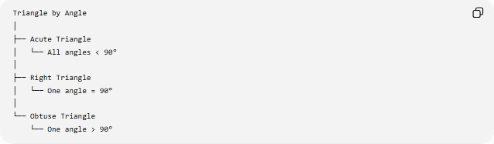
Triangle
Triangle by Angle
│
├── Acute Triangle
│ └── All angles < 90°
│
├── Right Triangle
│ └── One angle = 90°
│
└── Obtuse Triangle
└── One angle > 90°
Quadrilateral
A rectangle satisfies:
$$\boxed{A=B=C=D={90}^{∘}}.$$
A square also satisfies:
$$\boxed{A=B=C=D={90}^{∘}}.$$
Thus right-angle conditions are fundamental to the definition of rectangles and squares.

Algebraic Representation of Angle Conditions
# Source: AI Source: Provided by: [Data Path: Persons Table -> ID Column: 1, Name_En Column: Motasem Essam] -> From: [ChatGPT] on [7/25/2026]
Angles can be represented using variables.
Example
Suppose:
$$A=2x+10$$
and:
$$B=3x-20.$$
If they are equal:
$$A=B.$$
Therefore:
$$2x+10=3x-20.$$
So:
$$x=30.$$
Then:
$$A=2\left(30\right)+10={70}^{∘}.$$
and:
$$B=3\left(30\right)-20={70}^{∘}.$$
Thus the geometric equality condition becomes an algebraic equation.

Coordinate and Vector Angle Conditions
# Source: AI Source: Provided by: [Data Path: Persons Table -> ID Column: 1, Name_En Column: Motasem Essam] -> From: [ChatGPT] on [7/25/2026]
For vectors:
$$\vec{u},\vec{v},$$
the angle $θ$between them satisfies:
$$\boxed{\cos{θ}=\frac{\vec{u}⋅\vec{v}}{∣\vec{u}∣∣\vec{v}∣}}$$
Perpendicular Condition
If:
$$\vec{u}⋅\vec{v}=0,$$
then:
$$\boxed{θ={90}^{∘}}.$$
Thus a coordinate or vector condition can represent an angle condition.
Example
Let:
$$\vec{u}=\left(2 , 1\right), \vec{v}=\left(1 , -2\right).$$
Then:
$$\vec{u}⋅\vec{v}=2\left(1\right)+1\left(-2\right)=0.$$
Therefore:
$$\boxed{\vec{u}⊥\vec{v}}.$$

Important Angle Relationships
# Source: AI Source: Provided by: [Data Path: Persons Table -> ID Column: 1, Name_En Column: Motasem Essam] -> From: [ChatGPT] on [7/25/2026]
Some angle conditions produce other conditions automatically.
Complementary
$$A+B={90}^{∘}.$$
Supplementary
$$A+B={180}^{∘}.$$
Triangle
$$A+B+C={180}^{∘}.$$
Straight Angle
$$A={180}^{∘}.$$
Full Rotation
$$A={360}^{∘}.$$
Right Angle
$$A={90}^{∘}.$$
Vertical Angles
$$A=B.$$
Parallel Lines
$$\text{Corresponding angles are equal}.$$
Isosceles Triangle
$$AB=AC⇒B=C.$$

Angle Conditions and Other Geometric Conditions
# Source: AI Source: Provided by: [Data Path: Persons Table -> ID Column: 1, Name_En Column: Motasem Essam] -> From: [ChatGPT] on [7/25/2026]
Angle conditions frequently interact with other types of geometric conditions.
Length → Angle
$$AB=AC$$
can imply:
$$∠B=∠C.$$
Angle → Length
In a triangle:
$$A=B$$
implies:
$$a=b$$
where $a$and $b$are the opposite side lengths.
Angle → Perpendicularity
$$A={90}^{∘}$$
can imply:
$$l_{1}⊥l_{2}.$$
Angle → Parallelism
Equal corresponding or alternate interior angles can establish:
$$l_{1}∥l_{2}.$$
Therefore:
$$\boxed{\text{Angle Condition}→\text{Geometric Relationship}}$$

Angle Conditions in Geometric Proofs
# Source: AI Source: Provided by: [Data Path: Persons Table -> ID Column: 1, Name_En Column: Motasem Essam] -> From: [ChatGPT] on [7/25/2026]
Angle conditions are frequently used as givens or deduced facts.
Example
Given:
$$AB∥CD$$
and:
$$m∠A={70}^{∘}.$$
Using corresponding angles:
$$\boxed{m∠B={70}^{∘}}.$$
Another example:
Given:
$$AB=AC.$$
Then:
$$\boxed{∠B=∠C}$$
by the Isosceles Triangle Theorem.
Thus:
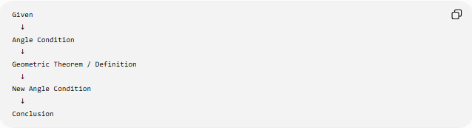
Given
↓
Angle Condition
↓
Geometric Theorem / Definition
↓
New Angle Condition
↓
Conclusion

Classification Summary
# Source: AI Source: Provided by: [Data Path: Persons Table -> ID Column: 1, Name_En Column: Motasem Essam] -> From: [ChatGPT] on [7/25/2026]
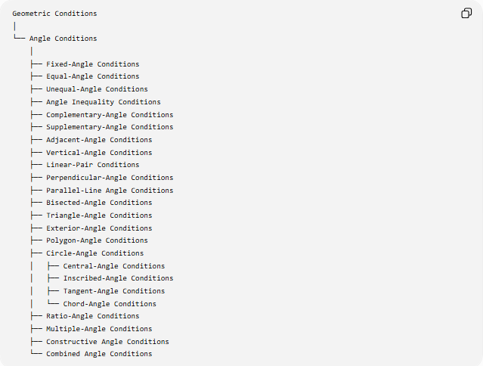
Geometric Conditions
│
└── Angle Conditions
│
├── Fixed-Angle Conditions
├── Equal-Angle Conditions
├── Unequal-Angle Conditions
├── Angle Inequality Conditions
├── Complementary-Angle Conditions
├── Supplementary-Angle Conditions
├── Adjacent-Angle Conditions
├── Vertical-Angle Conditions
├── Linear-Pair Conditions
├── Perpendicular-Angle Conditions
├── Parallel-Line Angle Conditions
├── Bisected-Angle Conditions
├── Triangle-Angle Conditions
├── Exterior-Angle Conditions
├── Polygon-Angle Conditions
├── Circle-Angle Conditions
│ ├── Central-Angle Conditions
│ ├── Inscribed-Angle Conditions
│ ├── Tangent-Angle Conditions
│ └── Chord-Angle Conditions
├── Ratio-Angle Conditions
├── Multiple-Angle Conditions
├── Constructive Angle Conditions
└── Combined Angle Conditions

Key Formulas
# Source: AI Source: Provided by: [Data Path: Persons Table -> ID Column: 1, Name_En Column: Motasem Essam] -> From: [ChatGPT] on [7/25/2026]
Fixed angle
$$\boxed{m∠A=θ}$$
Equal angles
$$\boxed{m∠A=m∠B}$$
Complementary angles
$$\boxed{A+B={90}^{∘}}$$
Supplementary angles
$$\boxed{A+B={180}^{∘}}$$
Triangle
$$\boxed{A+B+C={180}^{∘}}$$
Exterior angle
$$\boxed{E=A+B}$$
Polygon interior-angle sum
$$\boxed{S=\left(n-2\right){180}^{∘}}$$
Regular polygon interior angle
$$\boxed{A=\frac{\left(n-2\right){180}^{∘}}{n}}$$
Regular polygon exterior angle
$$\boxed{E=\frac{{360}^{∘}}{n}}$$
Central angle
$$\boxed{m∠_{\text{central}}=m\overset{^}{\text{arc}}}$$
Inscribed angle
$$\boxed{m∠_{\text{inscribed}}=\frac{1}{2}m\overset{^}{\text{arc}}}$$
Fixed-angle locus
$$\boxed{∠APB=θ}$$
produces appropriate circular arc(s).
Vector angle
$$\boxed{\cos{θ}=\frac{\vec{u}⋅\vec{v}}{∣\vec{u}∣∣\vec{v}∣}}$$

Important Distinctions
# Source: AI Source: Provided by: [Data Path: Persons Table -> ID Column: 1, Name_En Column: Motasem Essam] -> From: [ChatGPT] on [7/25/2026]
Angle Equality vs Angle Bisector
$$A=B$$
only says two angles have equal measures.
An angle bisector additionally specifies that a particular ray divides a larger angle into two equal parts:
$$∠ABD=∠DBC.$$
Supplementary vs Linear Pair
$$A+B={180}^{∘}$$
means the angles are supplementary.
A linear pair additionally requires them to be adjacent and their non-common sides to form a straight line.
Perpendicular vs Supplementary
Perpendicular lines produce:
$${90}^{∘}$$
angles, while supplementary angles sum to:
$${180}^{∘}.$$
Angle Condition vs Angle Measurement
The measurement:
$${60}^{∘}$$
is a value.
The condition:
$$m∠ABC={60}^{∘}$$
is a requirement imposed on the geometric configuration.

Key Points
# Source: AI Source: Provided by: [Data Path: Persons Table -> ID Column: 1, Name_En Column: Motasem Essam] -> From: [ChatGPT] on [7/25/2026]
- Angle Conditions specify, compare, or constrain angle measures and relationships.
- A fixed-angle condition can be written:
$$m∠A=θ.$$
- Equal-angle conditions use:
$$A=B.$$
- Angle inequalities use:
$$A>B, A<B.$$
- Complementary angles satisfy:
$$A+B={90}^{∘}.$$
- Supplementary angles satisfy:
$$A+B={180}^{∘}.$$
- A triangle always satisfies:
$$A+B+C={180}^{∘}.$$
- A polygon with $n$sides has interior-angle sum:
$$\left(n-2\right){180}^{∘}.$$
- Parallel lines create important equal and supplementary angle conditions.
- Perpendicular lines create ${90}^{∘}$angle conditions.
- Angle bisectors create equal-angle conditions.
- Circle geometry creates central-angle, inscribed-angle, tangent-angle, and chord-angle conditions.
- Fixed-angle conditions can generate circular-arc loci.
- Angle conditions are heavily used in geometric proofs, constructions, classifications, and coordinate geometry.

Conclusion
# Source: AI Source: Provided by: [Data Path: Persons Table -> ID Column: 1, Name_En Column: Motasem Essam] -> From: [ChatGPT] on [7/25/2026]
Angle Conditions are a fundamental category of Geometric Conditions because they specify how angles must behave within a geometric configuration.
The central relationship is:
$$\boxed{\text{Angle Condition}→\text{Angular Relationship}→\text{Geometric Consequence}}$$
For example:
$$\boxed{m∠A={90}^{∘}→\text{Right Angle}→\text{Perpendicular Relationship}} \\ \boxed{∠A=∠B→\text{Equal Angles}→\text{Possible Isosceles/Parallel-Line Relationship}} \\ \boxed{∠APB=θ→\text{Fixed-Angle Locus}→\text{Circular Arc(s)}}$$
Thus, angle conditions connect angle measurement, equality, inequalities, parallelism, perpendicularity, triangles, polygons, circles, loci, constructions, and geometric proofs.

